Project 1 Planning Document

Erin McAnany, Parth Contractor, Shantanu Jamble

Tool: We plan to use Unity for this project because it is the tool we are most familiar with and comfortable with using. We also found Asset Packs in the Unity store that worked for the environment idea we wanted to create.

For Version Control we plan to use Github.

Description: Our environment is divided into two parts, which are separated by a trench filled with fire. These two sides of the land are connected by bridges made of rock. On one side of the land you will find a human civilization. To the north of the civilization is a lake inside a forest. The south of the civilization is protected by mountains. On the other side of the trench, is a dead forest. On a hill to the north of the dead forest is an abandoned gold mine, which is filled with the debris of mining equipment and abandoned warehouses. To the south of the dead forest is an eerie graveyard, which has some dug up graves and missing or broken headstones.

Narrative: A legion of demons is dead set on opening the gates of hell in order to release the trapped demons and the devil. They perform a ritual in order to accomplish their task. However, in a nearby village, a group of wizards catches wind of the demons’ plan. They realize it's too late to stop the ritual from being completed, but they know they can protect their town from the aftermath of the ritual. When the gates of hell are opened, the land is split into two parts separated by a fire trench. The area where the Wizards were able to put up the spell shield was not affected and it seemed like a normal day to the population of the village. However, in the unprotected part of the land, the effects of the ritual and the demons escaping hell was clearly evident. The trees in the forest were burning or dead. The functional mine on top the hill got hit by an earthquake which left it in a wrecked condition. The people who worked there have no option but to abandon it. The demons later raided the graveyard, raising an army of the dead to take over the world.

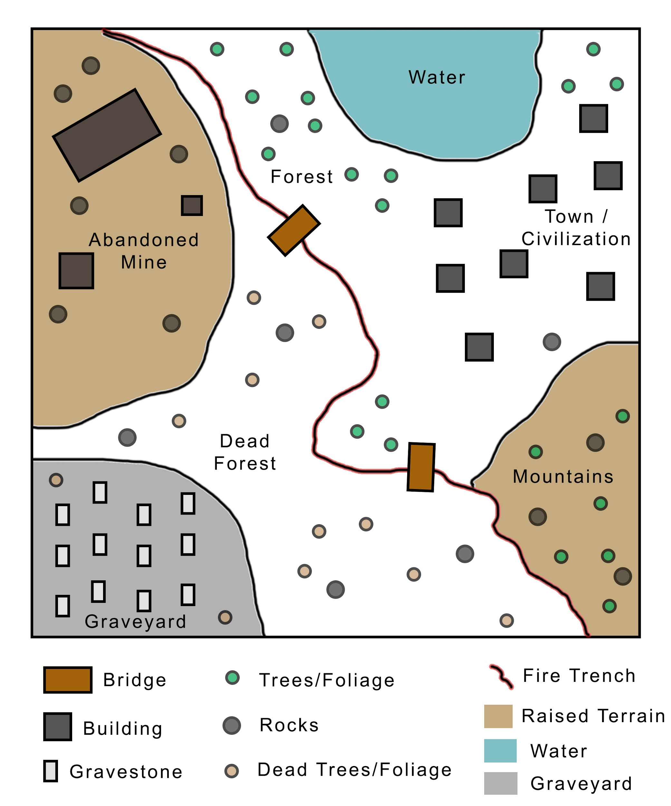

Task Distribution:

Parth Contractor: Level design (Paper design), narrative, programming, documentation

Shantanu Jamble: Programming, narrative, Asset placements, documentation

Erin McAnany: Team Lead, Level Design (Unity), Programming, Asset placements, Art, documentation

Running the environment: Since the environment is being built in Unity, it will have a unity build executable. Opening the executable will bring the player to the main scene. The player will be controlled by simple WASD keys through the keyboard. The camera will follow the player throughout the world through a third person perspective, hovering above and slightly behind the player.